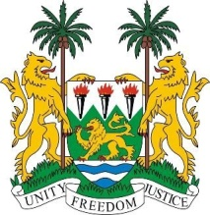
SIERRA LEONE
25th Session of the UPR

SUDAN

STATEMENT BY SIERRA LEONE

4 May 2016

Mr President,

Sierra Leone warmly welcomes the delegation of Sudan and thanks them for the presentation of their national report.

My delegation commends the establishment of a National Committee for Combatting Human Trafficking in 2014, as well as their ten-year national plan to promote and protect human rights. Similarly noteworthy is the National Quarter-Century Strategy, and following the elections of 2015, there is now a 30% participation of women in Parliament.

Sierra Leone encourages Sudan to further efforts to eliminate all forms of violence against women, ensure the protection of human rights defenders and civil society activists.

We are concerned by reports of internal armed conflicts which ravaged parts of Sudan, but are heartened that peace agreements and national dialogue are ongoing. Sierra Leone hopes that cooperation with international partners will continue in order to ensure sustainable peace and development in Sudan.

Recommendations:

- Sign and ratify the CAT and CEDAW.
- Raise the minimum age of marriage to 18
- Consider establishing a moratorium on the death penalty with a view to abolishing it.

Finally, Sierra Leone wishes Sudan a successful review.

Thank you, Mr President.

